**Git & GitHub Assignment**

Install GIT & make sure it is added into PATH.

Use GIT as local VCS. Steps to follow:

**1. Create a directory ‘project_dir’ & cd to ‘project_dir’.**

Manindra@LAPTOP-7IUNAFJF MINGW64 ~/OneDrive/Desktop/New folder (master)

$ mkdir project_dir

Manindra@LAPTOP-7IUNAFJF MINGW64 ~/OneDrive/Desktop/New folder (master)

$ cd project_dir

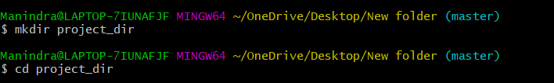

**2. Initialize git version database. (git init)**

Manindra@LAPTOP-7IUNAFJF MINGW64 ~/OneDrive/Desktop/New folder/project_dir (master)

$ git init

Initialized empty Git repository in C:/Users/Manindra/OneDrive/Desktop/New folder/project_dir/.git/



**3. Create a new file index.html.**

Manindra@LAPTOP-7IUNAFJF MINGW64 ~/OneDrive/Desktop/New folder/project_dir (master)

$ touch index.html



**4. Check the git status. You should find index.html as untracked file.**

Manindra@LAPTOP-7IUNAFJF MINGW64 ~/OneDrive/Desktop/New folder/project_dir (master)

$ git status

On branch master

No commits yet

Untracked files:

(use "git add <file>..." to include in what will be committed)

index.html

nothing added to commit but untracked files present (use "git add" to track)

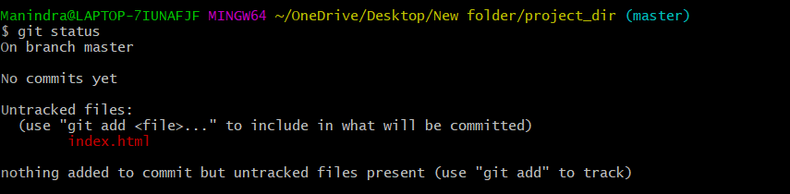

**5. Stage the index.html file.**

Manindra@LAPTOP-7IUNAFJF MINGW64 ~/OneDrive/Desktop/New folder/project_dir (master)

$ git add index.html

Manindra@LAPTOP-7IUNAFJF MINGW64 ~/OneDrive/Desktop/New folder/project_dir (master)

$ git status

On branch master

No commits yet

Changes to be committed:

(use "git rm --cached <file>..." to unstage)

new file: index.html

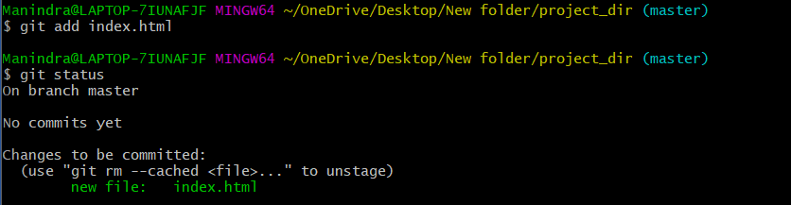

**6. Commit index.html**

Manindra@LAPTOP-7IUNAFJF MINGW64 ~/OneDrive/Desktop/New folder/project_dir (master)

$ git commit -m 'committing index file'

[master (root-commit) ef37c67] committing index file

1 file changed, 0 insertions(+), 0 deletions(-)

create mode 100644 index.html

Manindra@LAPTOP-7IUNAFJF MINGW64 ~/OneDrive/Desktop/New folder/project_dir (master)

$ git status

On branch master

nothing to commit, working tree clean

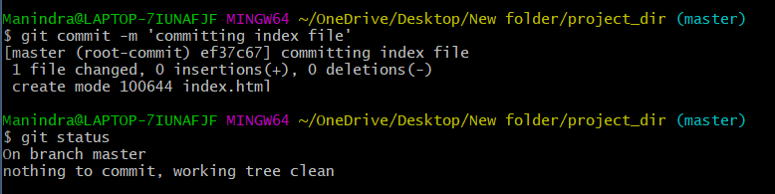

**7. Make few changes in index.html & create a new file info.txt file.**

Manindra@LAPTOP-7IUNAFJF MINGW64 ~/OneDrive/Desktop/New folder/project_dir (master)

$ vi index.html

Manindra@LAPTOP-7IUNAFJF MINGW64 ~/OneDrive/Desktop/New folder/project_dir (master)

$ touch info.txt

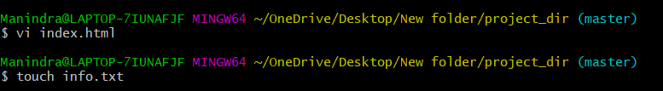

**8. Check git status. You should find index.html & info.txt as untracked files.**

Manindra@LAPTOP-7IUNAFJF MINGW64 ~/OneDrive/Desktop/New folder/project_dir (master)

$ git status

On branch master

Changes not staged for commit:

(use "git add <file>..." to update what will be committed)

(use "git restore <file>..." to discard changes in working directory)

modified: index.html

Untracked files:

(use "git add <file>..." to include in what will be committed)

info.txt

no changes added to commit (use "git add" and/or "git commit -a")

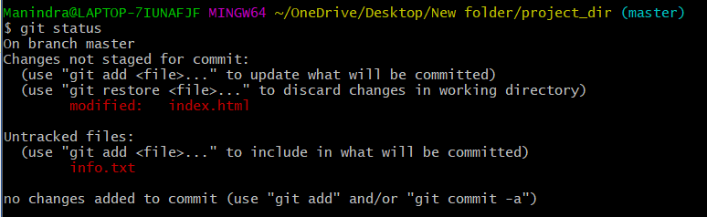

**9. Configure GIT to ignore all txt files.**

Manindra@LAPTOP-7IUNAFJF MINGW64 ~/OneDrive/Desktop/New folder/project_dir (master)

$ vi .gitignore

*.txt

~



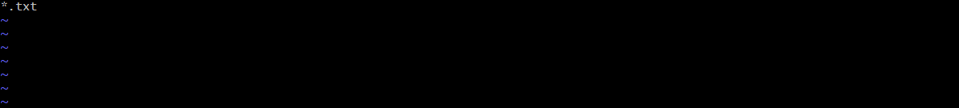

**10. Again check the git status. You should find only index.html as untracked file.**

Manindra@LAPTOP-7IUNAFJF MINGW64 ~/OneDrive/Desktop/New folder/project_dir (master)

$ git status

On branch master

Changes not staged for commit:

(use "git add <file>..." to update what will be committed)

(use "git restore <file>..." to discard changes in working directory)

modified: index.html

Untracked files:

(use "git add <file>..." to include in what will be committed)

.gitignore

no changes added to commit (use "git add" and/or "git commit -a")

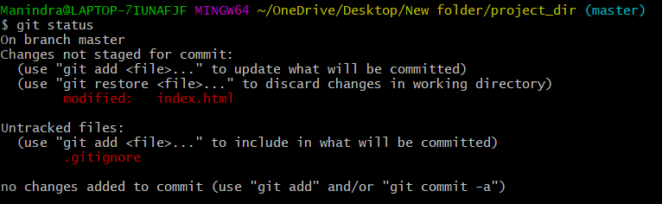

**11. State & commit index.html**

Manindra@LAPTOP-7IUNAFJF MINGW64 ~/OneDrive/Desktop/New folder/project_dir (master)

$ git commit -a -m 'committing updated index file'

warning: LF will be replaced by CRLF in index.html.

The file will have its original line endings in your working directory

[master 17f1286] committing updated index file

1 file changed, 1 insertion(+), 1 deletion(-)

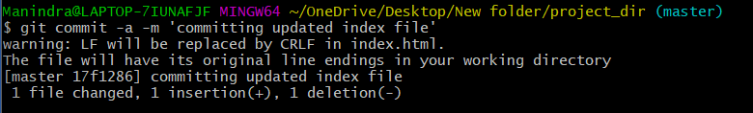

**12. Log all your comments so far.**

Manindra@LAPTOP-7IUNAFJF MINGW64 ~/OneDrive/Desktop/New folder/project_dir (master)

$ git log

commit 17f1286b4806f2c48c614e93dd426749463f5aa6 (HEAD -> master)

Author: unknown <nagamanindra7550@gmail.com>

Date: Fri Feb 4 15:57:45 2022 +0530

committing updated index file

commit bc9afc90390916ea7f4d22af93a3384a361d1ee4

Author: unknown <nagamanindra7550@gmail.com>

Date: Fri Feb 4 15:56:35 2022 +0530

committing updated index file

commit bf96952ce96f865cea01d0c649409bd963fe1570

Author: unknown <nagamanindra7550@gmail.com>

Date: Fri Feb 4 15:53:58 2022 +0530

committing updated index file

commit ef37c67866f4d39456356501e278e9743b5a39d7

Author: unknown <nagamanindra7550@gmail.com>

Date: Fri Feb 4 15:40:43 2022 +0530

committing index file

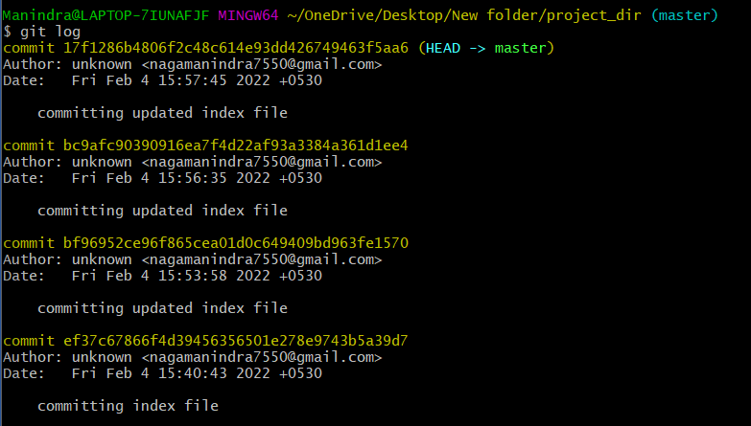

**13. Make some changes in index.html.**

Manindra@LAPTOP-7IUNAFJF MINGW64 ~/OneDrive/Desktop/New folder/project_dir (master)

$ vi index.html

Manindra@LAPTOP-7IUNAFJF MINGW64 ~/OneDrive/Desktop/New folder/project_dir (master)

$ git status

On branch master

Changes not staged for commit:

(use "git add <file>..." to update what will be committed)

(use "git restore <file>..." to discard changes in working directory)

modified: index.html

Untracked files:

(use "git add <file>..." to include in what will be committed)

.gitignore

no changes added to commit (use "git add" and/or "git commit -a")

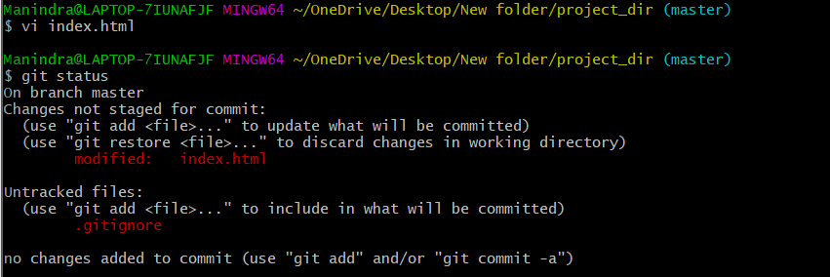

**14. Revert the change made in the previous step using git command.**

Manindra@LAPTOP-7IUNAFJF MINGW64 ~/OneDrive/Desktop/New folder/project_dir (master)

$ git restore index.html

Manindra@LAPTOP-7IUNAFJF MINGW64 ~/OneDrive/Desktop/New folder/project_dir (master)

$ git status

On branch master

Untracked files:

(use "git add <file>..." to include in what will be committed)

.gitignore

nothing added to commit but untracked files present (use "git add" to track)

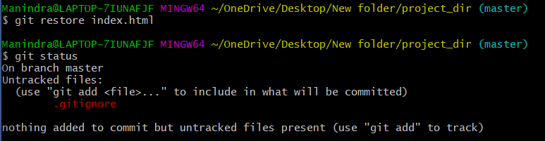

**15. Again change index.html.**

Manindra@LAPTOP-7IUNAFJF MINGW64 ~/OneDrive/Desktop/New folder/project_dir (master)

$ vi index.html

Manindra@LAPTOP-7IUNAFJF MINGW64 ~/OneDrive/Desktop/New folder/project_dir (master)

$ git status

On branch master

Changes not staged for commit:

(use "git add <file>..." to update what will be committed)

(use "git restore <file>..." to discard changes in working directory)

modified: index.html

Untracked files:

(use "git add <file>..." to include in what will be committed)

.gitignore

no changes added to commit (use "git add" and/or "git commit -a")

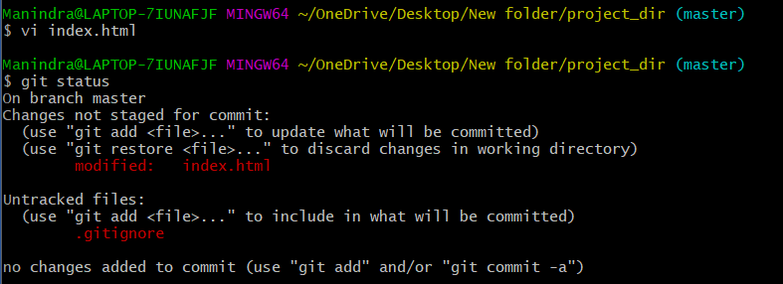

**16. Stage index.html**

Manindra@LAPTOP-7IUNAFJF MINGW64 ~/OneDrive/Desktop/New folder/project_dir (master)

$ git add index.html

Manindra@LAPTOP-7IUNAFJF MINGW64 ~/OneDrive/Desktop/New folder/project_dir (master)

$ git status

On branch master

Changes to be committed:

(use "git restore --staged <file>..." to unstage)

modified: index.html

Untracked files:

(use "git add <file>..." to include in what will be committed)

.gitignore

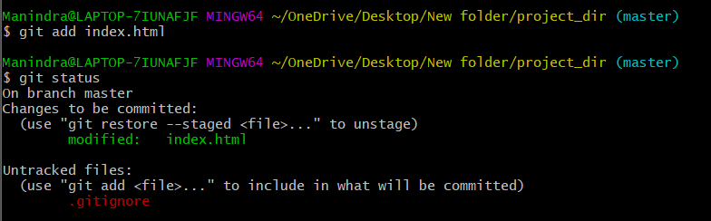

**17. Revert back the last stage.**

Manindra@LAPTOP-7IUNAFJF MINGW64 ~/OneDrive/Desktop/New folder/project_dir (master)

$ git reset

Unstaged changes after reset:

M index.html

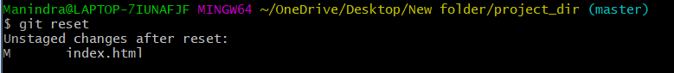

**18. Rename ‘add’ command to ‘my-add’.**

Manindra@LAPTOP-7IUNAFJF MINGW64 ~/OneDrive/Desktop/New folder/project_dir (master)

$ alias my_add='git add'



**19. Using my_add command Stage index.html again & commit the changes.**

Manindra@LAPTOP-7IUNAFJF MINGW64 ~/OneDrive/Desktop/New folder/project_dir (master)

$ my_add index.html

Manindra@LAPTOP-7IUNAFJF MINGW64 ~/OneDrive/Desktop/New folder/project_dir (master)

$ git status

On branch master

Changes to be committed:

(use "git restore --staged <file>..." to unstage)

modified: index.html

Untracked files:

(use "git add <file>..." to include in what will be committed)

.gitignore

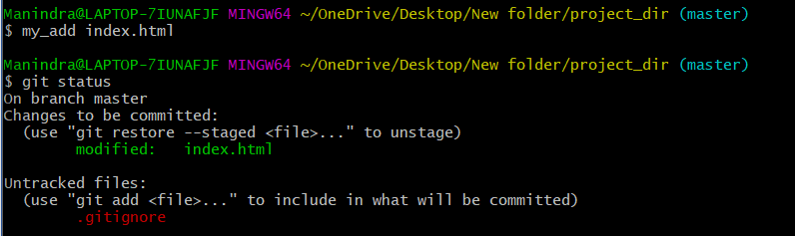

Manindra@LAPTOP-7IUNAFJF MINGW64 ~/OneDrive/Desktop/New folder/project_dir (master)

$ git commit -m 'committing after changeing add to my_add'

[master 9b91427] committing after changeing add to my_add

1 file changed, 1 insertion(+), 1 deletion(-)



**20. Revert the last commit.**

Manindra@LAPTOP-7IUNAFJF MINGW64 ~/OneDrive/Desktop/New folder/project_dir (master)

$ git status

On branch master

Changes to be committed:

(use "git restore --staged <file>..." to unstage)

modified: index.html

Untracked files:

(use "git add <file>..." to include in what will be committed)

.gitignore

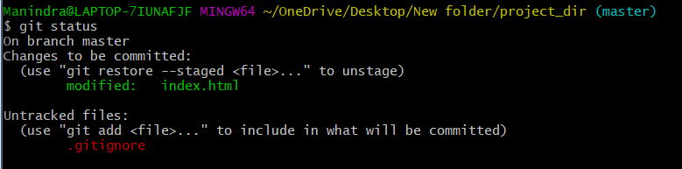

**GIT Branching Objective:**

**Commit HTML, CSS & JavaScript assignments into GIT.**

**SECTION-1 (HTML assignments) - Steps to follow:**

**21. First take a backup of your assignments & projects. This is required because due to incorrect GIT operation you may lose your files.**

**22. Create an empty directory ‘Assignments’ & cd to ‘Assignments’.**

Manindra@LAPTOP-7IUNAFJF MINGW64 ~/OneDrive/Desktop/New folder (master)

$ mkdir Assignments

Manindra@LAPTOP-7IUNAFJF MINGW64 ~/OneDrive/Desktop/New folder (master)

$ cd Assignments

Manindra@LAPTOP-7IUNAFJF MINGW64 ~/OneDrive/Desktop/New folder/Assignments (master)

$ git init

Initialized empty Git repository in C:/Users/Manindra/OneDrive/Desktop/New folder/Assignments/.git/

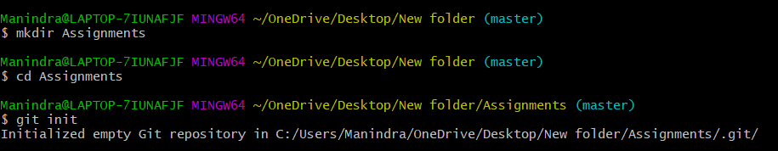

**23. Create a file README.txt inside ‘Assignments’ & write few lines about the contents of ‘Assignments’ folder.**

Manindra@LAPTOP-7IUNAFJF MINGW64 ~/OneDrive/Desktop/New folder/Assignments (master)

$ vi README.txt



**24. Commit README.txt file.**

Manindra@LAPTOP-7IUNAFJF MINGW64 ~/OneDrive/Desktop/New folder/Assignments (master)

$ git add README.txt

warning: LF will be replaced by CRLF in README.txt.

The file will have its original line endings in your working directory

Manindra@LAPTOP-7IUNAFJF MINGW64 ~/OneDrive/Desktop/New folder/Assignments (master)

$ git commit -m 'README file added'

[master (root-commit) 5ee67c6] README file added

1 file changed, 3 insertions(+)

create mode 100644 README.txt

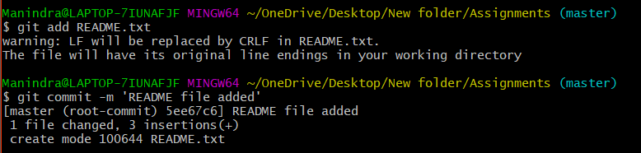

**25. Now create a new branch ‘html-assignments’.**

Manindra@LAPTOP-7IUNAFJF MINGW64 ~/OneDrive/Desktop/New folder/Assignments (master)

$ git branch html-assignments



**26. Switch to ‘html-assignments’ branch.**

Manindra@LAPTOP-7IUNAFJF MINGW64 ~/OneDrive/Desktop/New folder/Assignments (master)

$ git checkout html-assignments

Switched to branch 'html-assignments'



**27. Copy all HTML assignments inside ‘Assignments’ folder.**

Manindra@LAPTOP-7IUNAFJF MINGW64 ~/OneDrive/Desktop/New folder/Assignments (html-assignments)

$ git add *.html

warning: LF will be replaced by CRLF in 404.html.

The file will have its original line endings in your working directory

warning: LF will be replaced by CRLF in all-tags.html.

The file will have its original line endings in your working directory

warning: LF will be replaced by CRLF in blank.html.

The file will have its original line endings in your working directory

warning: LF will be replaced by CRLF in css-selectors.html.

The file will have its original line endings in your working directory

warning: LF will be replaced by CRLF in index.html.

The file will have its original line endings in your working directory

warning: LF will be replaced by CRLF in launcher.html.

The file will have its original line endings in your working directory

warning: LF will be replaced by CRLF in lorem-ipsum.html.

The file will have its original line endings in your working directory

warning: LF will be replaced by CRLF in pagebreaks.html.

The file will have its original line endings in your working directory

warning: LF will be replaced by CRLF in template.html.

The file will have its original line endings in your working directory

Manindra@LAPTOP-7IUNAFJF MINGW64 ~/OneDrive/Desktop/New folder/Assignments (html-assignments)

$ git status

On branch html-assignments

Changes to be committed:

(use "git restore --staged <file>..." to unstage)

new file: 404.html

new file: all-tags.html

new file: blank.html

new file: css-selectors.html

new file: index.html

new file: launcher.html

new file: lorem-ipsum.html

new file: pagebreaks.html

new file: template.html

Untracked files:

(use "git add <file>..." to include in what will be committed)

app.js

baseline.css

basic.js

browserconfig.xml

build-scripts.js

file_content.js

file_existence.js

karma.conf.js

main.css

normalize.css

promise.js

settings.js

snapshot.js

style.css

webpack.config.js

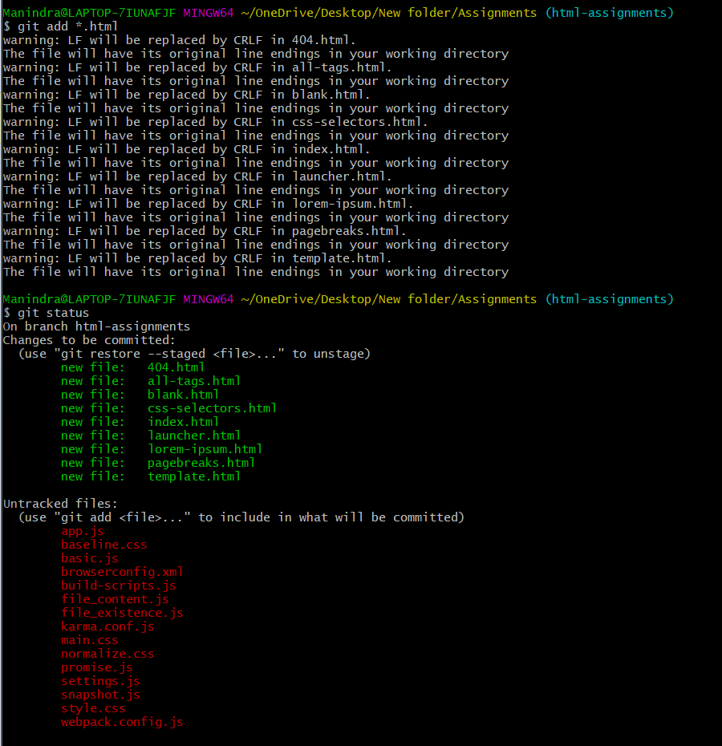

**28. Commit HTML assignments into ‘html-assignments’ branch.**

Manindra@LAPTOP-7IUNAFJF MINGW64 ~/OneDrive/Desktop/New folder/Assignments (html-assignments)

$ git commit -m 'html files added'

[html-assignments bcc92d5] html files added

9 files changed, 683 insertions(+)

create mode 100644 404.html

create mode 100644 all-tags.html

create mode 100644 blank.html

create mode 100644 css-selectors.html

create mode 100644 index.html

create mode 100644 launcher.html

create mode 100644 lorem-ipsum.html

create mode 100644 pagebreaks.html

create mode 100644 template.html

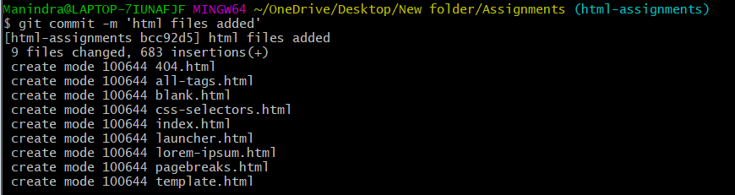

**29. Make minor changes into few files belonging to ‘html-assignments’ branch.**

Manindra@LAPTOP-7IUNAFJF MINGW64 ~/OneDrive/Desktop/New folder/Assignments (html-assignments)

$ vi blank.html

Manindra@LAPTOP-7IUNAFJF MINGW64 ~/OneDrive/Desktop/New folder/Assignments (html-assignments)

$ vi index.html

Manindra@LAPTOP-7IUNAFJF MINGW64 ~/OneDrive/Desktop/New folder/Assignments (html-assignments)

$ git status

On branch html-assignments

Changes not staged for commit:

(use "git add <file>..." to update what will be committed)

(use "git restore <file>..." to discard changes in working directory)

modified: blank.html

modified: index.html

Untracked files:

(use "git add <file>..." to include in what will be committed)

app.js

baseline.css

basic.js

browserconfig.xml

build-scripts.js

file_content.js

file_existence.js

karma.conf.js

main.css

normalize.css

promise.js

settings.js

snapshot.js

style.css

webpack.config.js

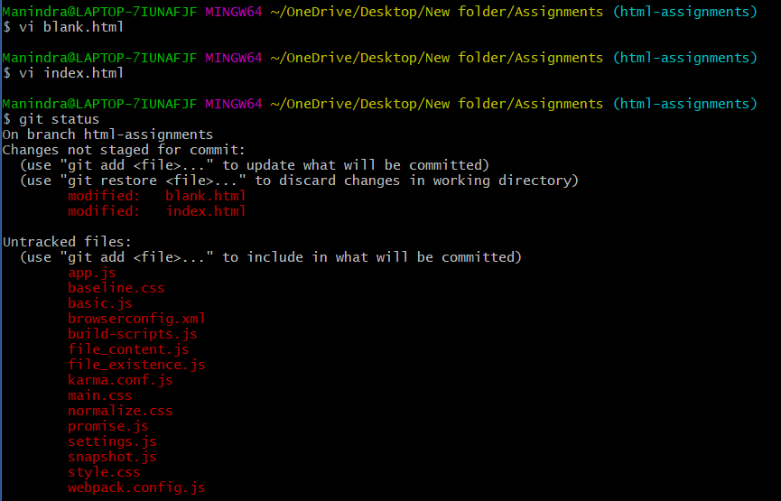

**30. Commit those changed files.**

Manindra@LAPTOP-7IUNAFJF MINGW64 ~/OneDrive/Desktop/New folder/Assignments (html-assignments)

$ git commit -a -m 'commitiing edited files'

warning: LF will be replaced by CRLF in blank.html.

The file will have its original line endings in your working directory

warning: LF will be replaced by CRLF in index.html.

The file will have its original line endings in your working directory

[html-assignments 166993b] commitiing edited files

2 files changed, 2 insertions(+), 1 deletion(-)

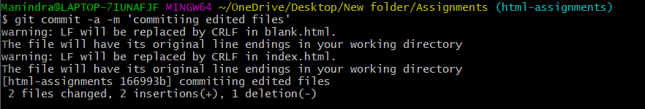

**31. Switch to master branch.**

Manindra@LAPTOP-7IUNAFJF MINGW64 ~/OneDrive/Desktop/New folder/Assignments (html-assignments)

$ git checkout master

Switched to branch 'master'



**32. Make minor changes into README.txt file & commit those changes into master.**

Manindra@LAPTOP-7IUNAFJF MINGW64 ~/OneDrive/Desktop/New folder/Assignments (master)

$ vi README.txt

Manindra@LAPTOP-7IUNAFJF MINGW64 ~/OneDrive/Desktop/New folder/Assignments (master)

$ git commit -a -m 'readme file edited in master'

warning: LF will be replaced by CRLF in README.txt.

The file will have its original line endings in your working directory

[master b4679a6] readme file edited in master

1 file changed, 1 insertion(+)

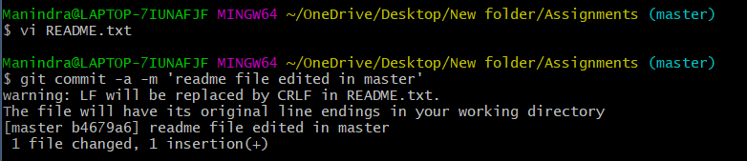

**33. Again switch to ‘html-assignments’ branch.**

Manindra@LAPTOP-7IUNAFJF MINGW64 ~/OneDrive/Desktop/New folder/Assignments (master)

$ git checkout html-assignments

Switched to branch 'html-assignments'



**34. Make minor changes into few files belonging to ‘html-assignments’ branch.**

Manindra@LAPTOP-7IUNAFJF MINGW64 ~/OneDrive/Desktop/New folder/Assignments (html-assignments)

$ vi blank.html

Manindra@LAPTOP-7IUNAFJF MINGW64 ~/OneDrive/Desktop/New folder/Assignments (html-assignments)

$ vi index.html

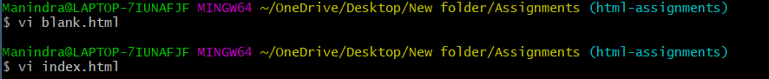

**35. Commit those changes.**

Manindra@LAPTOP-7IUNAFJF MINGW64 ~/OneDrive/Desktop/New folder/Assignments (html-assignments)

$ git commit -a -m 'html file edited in brach'

[html-assignments 7d4c526] html file edited in brach

2 files changed, 1 insertion(+), 2 deletions(-)



**36. Switch to master.**

Manindra@LAPTOP-7IUNAFJF MINGW64 ~/OneDrive/Desktop/New folder/Assignments (html-assignments)

$ git checkout master

Switched to branch 'master'



**37. Merge ‘html-assignments’ branch into master. Confirm all html assignments are shown in master.**

Manindra@LAPTOP-7IUNAFJF MINGW64 ~/OneDrive/Desktop/New folder/Assignments (master)

$ git merge html-assignments

Merge made by the 'ort' strategy.

404.html | 62 ++++++++++++

all-tags.html | 284 +++++++++++++++++++++++++++++++++++++++++++++++++++++

blank.html | 9 ++

css-selectors.html | 63 ++++++++++++

index.html | 35 +++++++

launcher.html | 82 ++++++++++++++++

lorem-ipsum.html | 21 ++++

pagebreaks.html | 83 ++++++++++++++++

template.html | 44 +++++++++

9 files changed, 683 insertions(+)

create mode 100644 404.html

create mode 100644 all-tags.html

create mode 100644 blank.html

create mode 100644 css-selectors.html

create mode 100644 index.html

create mode 100644 launcher.html

create mode 100644 lorem-ipsum.html

create mode 100644 pagebreaks.html

create mode 100644 template.html

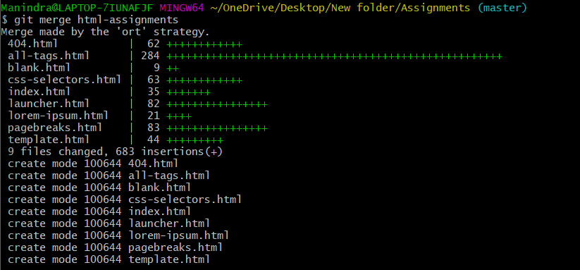

Manindra@LAPTOP-7IUNAFJF MINGW64 ~/OneDrive/Desktop/New folder/Assignments (master)

$ ls

404.html all-tags.html browserconfig.xml index.html lorem-ipsum.html template.html

README.txt blank.html css-selectors.html launcher.html pagebreaks.html



**38. Finally delete the ‘html-assignments’ branch.**

Manindra@LAPTOP-7IUNAFJF MINGW64 ~/OneDrive/Desktop/New folder/Assignments (master)

$ git branch -d html-assignments

Deleted branch html-assignments (was 7d4c526).



**SECTION-2 - (CSS assignments)**

**Steps to follow:**

**1. Create a new branch ‘css-assignments’.**

Manindra@LAPTOP-7IUNAFJF MINGW64 ~/OneDrive/Desktop/New folder/Assignments (master)

$ git branch css-assignments



**2. Switch to ‘css-assignments’ branch.**

Manindra@LAPTOP-7IUNAFJF MINGW64 ~/OneDrive/Desktop/New folder/Assignments (master)

$ git checkout css-assignments

Switched to branch 'css-assignments'



**3. Copy all CSS assignments inside ‘Assignments’ folder.**

Manindra@LAPTOP-7IUNAFJF MINGW64 ~/OneDrive/Desktop/New folder/Assignments (css-assignments)

$ git add *.css

warning: LF will be replaced by CRLF in baseline.css.

The file will have its original line endings in your working directory

warning: LF will be replaced by CRLF in normalize.css.

The file will have its original line endings in your working directory

warning: LF will be replaced by CRLF in style.css.

The file will have its original line endings in your working directory

Manindra@LAPTOP-7IUNAFJF MINGW64 ~/OneDrive/Desktop/New folder/Assignments (css-assignments)

$ git status

On branch css-assignments

Changes to be committed:

(use "git restore --staged <file>..." to unstage)

new file: baseline.css

new file: main.css

new file: normalize.css

new file: style.css

Untracked files:

(use "git add <file>..." to include in what will be committed)

app.js

basic.js

browserconfig.xml

build-scripts.js

file_content.js

file_existence.js

karma.conf.js

promise.js

settings.js

snapshot.js

webpack.config.js

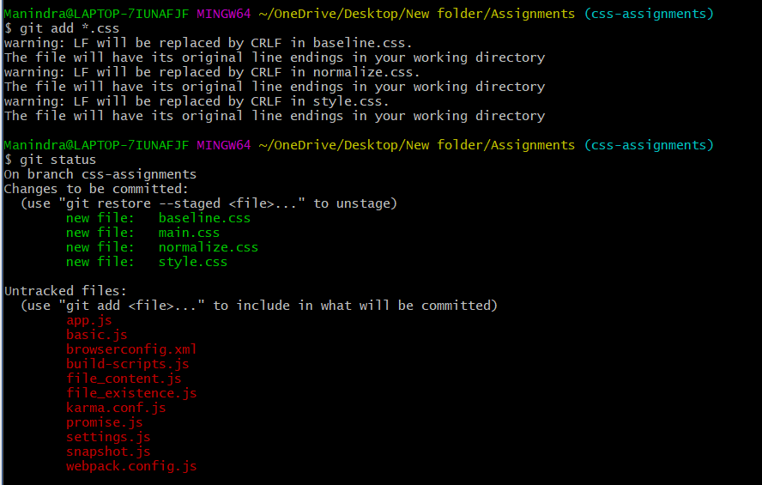

**4. Commit CSS assignments into ‘css-assignments’ branch.**

Manindra@LAPTOP-7IUNAFJF MINGW64 ~/OneDrive/Desktop/New folder/Assignments (css-assignments)

$ git commit -m 'css files added'

[css-assignments 8eb81f8] css files added

4 files changed, 600 insertions(+)

create mode 100644 baseline.css

create mode 100644 main.css

create mode 100644 normalize.css

create mode 100644 style.css

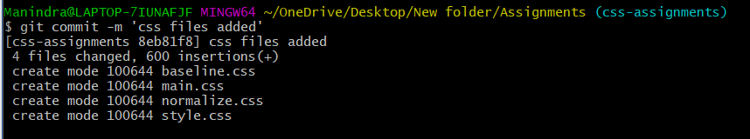

**5. Make minor changes into README.txt file on line 1 belonging to ‘css-assignments’ branch.**

Manindra@LAPTOP-7IUNAFJF MINGW64 ~/OneDrive/Desktop/New folder/Assignments (css-assignments)

$ vi README.txt



**6. Commit those changed files.**

Manindra@LAPTOP-7IUNAFJF MINGW64 ~/OneDrive/Desktop/New folder/Assignments (css-assignments)

$ git commit -a -m 'readme file edited'

[css-assignments 2cd74cb] readme file edited

1 file changed, 1 insertion(+), 1 deletion(-)



**7. Switch to master branch.**

Manindra@LAPTOP-7IUNAFJF MINGW64 ~/OneDrive/Desktop/New folder/Assignments (css-assignments)

$ git checkout master

Switched to branch 'master'



**8. Make minor changes into README.txt file on line 3 & commit those changes into master.**

Manindra@LAPTOP-7IUNAFJF MINGW64 ~/OneDrive/Desktop/New folder/Assignments (master)

$ vi README.txt

Manindra@LAPTOP-7IUNAFJF MINGW64 ~/OneDrive/Desktop/New folder/Assignments (master)

$ git commit -a -m 'readme file edited and added in master'

[master aab51a7] readme file edited and added in master

1 file changed, 1 insertion(+), 1 deletion(-)

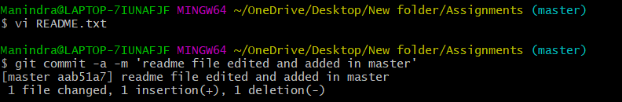

**9. Again switch to ‘css-assignments’ branch.**

Manindra@LAPTOP-7IUNAFJF MINGW64 ~/OneDrive/Desktop/New folder/Assignments (master)

$ git checkout css-assignments

Switched to branch 'css-assignments'



**10. Make minor changes into few files belonging to ‘css-assignments’ branch.**

Manindra@LAPTOP-7IUNAFJF MINGW64 ~/OneDrive/Desktop/New folder/Assignments (css-assignments)

$ vi main.css

Manindra@LAPTOP-7IUNAFJF MINGW64 ~/OneDrive/Desktop/New folder/Assignments (css-assignments)

$ vi style.css

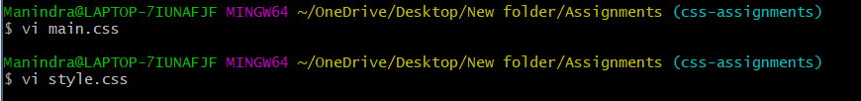

**11. Commit those changes.**

Manindra@LAPTOP-7IUNAFJF MINGW64 ~/OneDrive/Desktop/New folder/Assignments (css-assignments)

$ git commit -a -m 'css file edited and added in branch'

warning: LF will be replaced by CRLF in main.css.

The file will have its original line endings in your working directory

[css-assignments addd768] css file edited and added in branch

2 files changed, 3 insertions(+), 1 deletion(-)

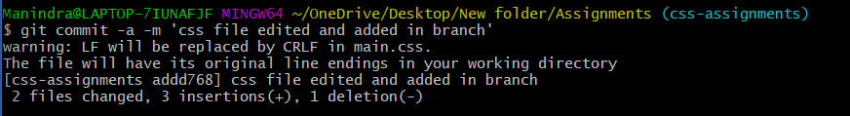

**12. Switch to master.**

Manindra@LAPTOP-7IUNAFJF MINGW64 ~/OneDrive/Desktop/New folder/Assignments (css-assignments)

$ git checkout master

Switched to branch 'master'



**13. Merge ‘css-assignments’ branch into master. Confirm all css assignments are shown in master.**

Manindra@LAPTOP-7IUNAFJF MINGW64 ~/OneDrive/Desktop/New folder/Assignments (master)

$ git merge css-assignments

Auto-merging README.txt

Merge made by the 'ort' strategy.

README.txt | 2 +-

baseline.css | 4 +

main.css | 2 +

normalize.css | 349 ++++++++++++++++++++++++++++++++++++++++++++++++++++++++++

style.css | 247 +++++++++++++++++++++++++++++++++++++++++

5 files changed, 603 insertions(+), 1 deletion(-)

create mode 100644 baseline.css

create mode 100644 main.css

create mode 100644 normalize.css

create mode 100644 style.css

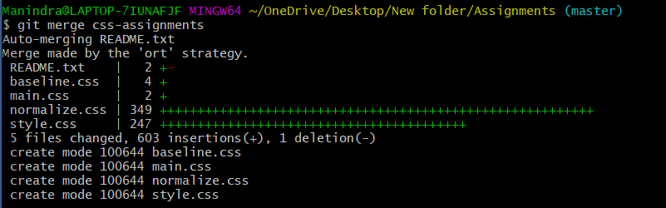

Manindra@LAPTOP-7IUNAFJF MINGW64 ~/OneDrive/Desktop/New folder/Assignments (master)

$ ls

404.html baseline.css css-selectors.html lorem-ipsum.html pagebreaks.html

README.txt blank.html index.html main.css style.css

all-tags.html browserconfig.xml launcher.html normalize.css template.html

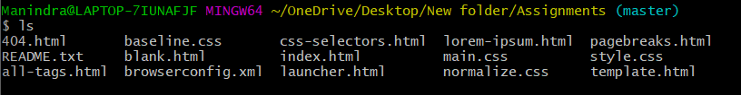

**14. Finally delete the ‘css-assignments’ branch.**

Manindra@LAPTOP-7IUNAFJF MINGW64 ~/OneDrive/Desktop/New folder/Assignments (master)

$ git branch -d css-assignments

Deleted branch css-assignments (was addd768).



**SECTION-3 - (JavaScript assignments)**

**Steps to follow:**

**1. Create a new branch ‘js-assignments’.**

Manindra@LAPTOP-7IUNAFJF MINGW64 ~/OneDrive/Desktop/New folder/Assignments (master)

$ git branch js-assignments



**2. Switch to ‘js-assignments’ branch.**

Manindra@LAPTOP-7IUNAFJF MINGW64 ~/OneDrive/Desktop/New folder/Assignments (master)

$ git checkout js-assignments

Switched to branch 'js-assignments'



**3. Copy all JavaScript assignments inside ‘Assignments’ folder.**

Manindra@LAPTOP-7IUNAFJF MINGW64 ~/OneDrive/Desktop/New folder/Assignments (js-assignments)

$ git add *.js

warning: LF will be replaced by CRLF in basic.js.

The file will have its original line endings in your working directory

warning: LF will be replaced by CRLF in build-scripts.js.

The file will have its original line endings in your working directory

warning: LF will be replaced by CRLF in file_content.js.

The file will have its original line endings in your working directory

warning: LF will be replaced by CRLF in file_existence.js.

The file will have its original line endings in your working directory

warning: LF will be replaced by CRLF in karma.conf.js.

The file will have its original line endings in your working directory

warning: LF will be replaced by CRLF in promise.js.

The file will have its original line endings in your working directory

warning: LF will be replaced by CRLF in settings.js.

The file will have its original line endings in your working directory

warning: LF will be replaced by CRLF in snapshot.js.

The file will have its original line endings in your working directory

warning: LF will be replaced by CRLF in webpack.config.js.

The file will have its original line endings in your working directory

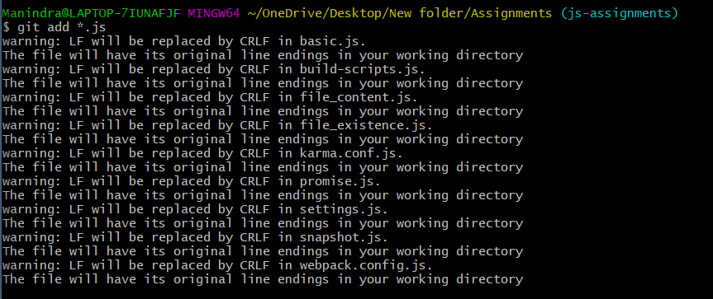

**4. Commit JavaScript assignments into ‘js-assignments’ branch.**

Manindra@LAPTOP-7IUNAFJF MINGW64 ~/OneDrive/Desktop/New folder/Assignments (js-assignments)

$ git commit -m 'js file added in branch'

[js-assignments 716777f] js file added in branch

10 files changed, 639 insertions(+)

create mode 100644 app.js

create mode 100644 basic.js

create mode 100644 build-scripts.js

create mode 100644 file_content.js

create mode 100644 file_existence.js

create mode 100644 karma.conf.js

create mode 100644 promise.js

create mode 100644 settings.js

create mode 100644 snapshot.js

create mode 100644 webpack.config.js

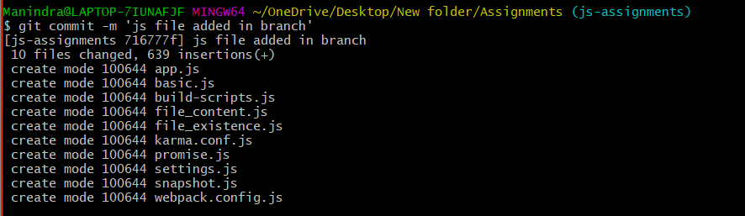

**5. Make minor changes into README.txt file on line 1 belonging to ‘js-assignments’ branch.**

Manindra@LAPTOP-7IUNAFJF MINGW64 ~/OneDrive/Desktop/New folder/Assignments (js-assignments)

$ vi README.txt



**6. Commit those changed files.**

Manindra@LAPTOP-7IUNAFJF MINGW64 ~/OneDrive/Desktop/New folder/Assignments (js-assignments)

$ git commit -a -m 'readme file editted and added in branch'

[js-assignments c67850b] readme file editted and added in branch

1 file changed, 1 insertion(+), 1 deletion(-)



**7. Switch to master branch.**

Manindra@LAPTOP-7IUNAFJF MINGW64 ~/OneDrive/Desktop/New folder/Assignments (js-assignments)

$ git checkout master

Switched to branch 'master'



**8. Make minor changes into README.txt file on line 1 & commit those changes into master.**

Manindra@LAPTOP-7IUNAFJF MINGW64 ~/OneDrive/Desktop/New folder/Assignments (master)

$ vi README.txt

Manindra@LAPTOP-7IUNAFJF MINGW64 ~/OneDrive/Desktop/New folder/Assignments (master)

$ git commit -a -m 'readme file editted and added in master'

[master e93dceb] readme file editted and added in master

1 file changed, 3 insertions(+), 1 deletion(-)

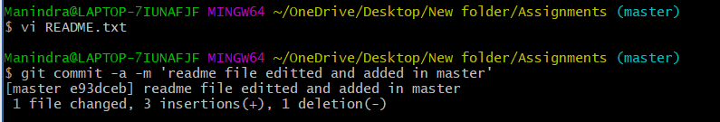

**9. Again switch to ‘js-assignments’ branch.**

Manindra@LAPTOP-7IUNAFJF MINGW64 ~/OneDrive/Desktop/New folder/Assignments (master)

$ git checkout js-assignments

Switched to branch 'js-assignments'



**10. Make minor changes into few files belonging to ‘js-assignments’ branch.**

Manindra@LAPTOP-7IUNAFJF MINGW64 ~/OneDrive/Desktop/New folder/Assignments (js-assignments)

$ vi app.js

Manindra@LAPTOP-7IUNAFJF MINGW64 ~/OneDrive/Desktop/New folder/Assignments (js-assignments)

$ vi basic.js

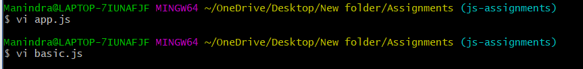

**11. Commit those changes.**

Manindra@LAPTOP-7IUNAFJF MINGW64 ~/OneDrive/Desktop/New folder/Assignments (js-assignments)

$ git commit -a -m 'js file editted and added in branch'

warning: LF will be replaced by CRLF in app.js.

The file will have its original line endings in your working directory

[js-assignments b2ed48c] js file editted and added in branch

2 files changed, 2 insertions(+), 1 deletion(-)

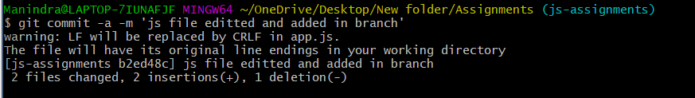

**12. Switch to master.**

Manindra@LAPTOP-7IUNAFJF MINGW64 ~/OneDrive/Desktop/New folder/Assignments (js-assignments)

$ git checkout master

Switched to branch 'master'



**13. Merge ‘js-assignments’ branch into master. Confirm all JavaScript assignments are shown in master.**

Manindra@LAPTOP-7IUNAFJF MINGW64 ~/OneDrive/Desktop/New folder/Assignments (master)

$ git merge js-assignments

Auto-merging README.txt

CONFLICT (content): Merge conflict in README.txt

Automatic merge failed; fix conflicts and then commit the result.

Manindra@LAPTOP-7IUNAFJF MINGW64 ~/OneDrive/Desktop/New folder/Assignments (master|MERGING)

$ git diff README.txt

**diff --cc README.txt**

**index 87b61af,496290d..0000000**

**--- a/README.txt**

**+++ b/README.txt**

@@@ -1,4 -1,4 +1,8 @@@

++<<<<<<< HEAD

+this is Assigments folder

++=======

+ Assigments folder is created

++>>>>>>> js-assignments

this folder is created to complete my git and github assignment

we will add HTML,CSS,JS files to this folder

HTML files are added

Manindra@LAPTOP-7IUNAFJF MINGW64 ~/OneDrive/Desktop/New folder/Assignments (master|MERGING)

$ vi README.txt

Manindra@LAPTOP-7IUNAFJF MINGW64 ~/OneDrive/Desktop/New folder/Assignments (master|MERGING)

$ git merge --continue

error: Committing is not possible because you have unmerged files.

hint: Fix them up in the work tree, and then use 'git add/rm <file>'

hint: as appropriate to mark resolution and make a commit.

fatal: Exiting because of an unresolved conflict.

U README.txt

Manindra@LAPTOP-7IUNAFJF MINGW64 ~/OneDrive/Desktop/New folder/Assignments (master|MERGING)

$ git merge js-assignments

error: Merging is not possible because you have unmerged files.

hint: Fix them up in the work tree, and then use 'git add/rm <file>'

hint: as appropriate to mark resolution and make a commit.

fatal: Exiting because of an unresolved conflict.

Manindra@LAPTOP-7IUNAFJF MINGW64 ~/OneDrive/Desktop/New folder/Assignments (master|MERGING)

$ git commit -a -m 'merge bugs fixed'

[master 1c4b44f] merge bugs fixed

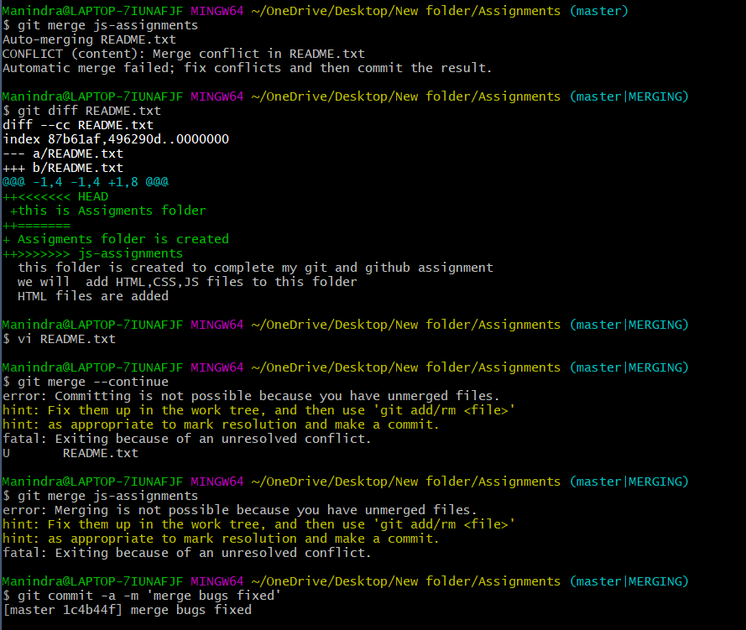

**14. Finally delete the ‘js-assignments’ branch.**

Manindra@LAPTOP-7IUNAFJF MINGW64 ~/OneDrive/Desktop/New folder/Assignments (master)

$ git branch -d js-assignments

Deleted branch js-assignments (was b2ed48c).



**GIT Remoting Objective:**

**Pushing source code into GITHUB & collaborate team members.**

**SECTION-1 (Pushing assignments to remote repository) –**

**Steps to follow:**

**39. Create a github account if you do not have already.**

**40. Login on into github account.**

**41. Create new public repository ‘freshersbatch-oct16’.**

**42. Commit & push any sample file to this repository under ‘Assignments’ directory.**

Manindra@LAPTOP-7IUNAFJF MINGW64 ~/OneDrive/Desktop/New folder/Assignments (master)

$ git remote add origin https://github.com/NagaManindra/freshersbatch-oct16.git

Manindra@LAPTOP-7IUNAFJF MINGW64 ~/OneDrive/Desktop/New folder/Assignments (master)

$ git push origin master

Enumerating objects: 92, done.

Counting objects: 100% (92/92), done.

Delta compression using up to 8 threads

Compressing objects: 100% (71/71), done.

Writing objects: 100% (92/92), 25.71 KiB | 2.34 MiB/s, done.

Total 92 (delta 28), reused 0 (delta 0), pack-reused 0

remote: Resolving deltas: 100% (28/28), done.

To https://github.com/NagaManindra/freshersbatch-oct16.git

* [new branch] master -> master

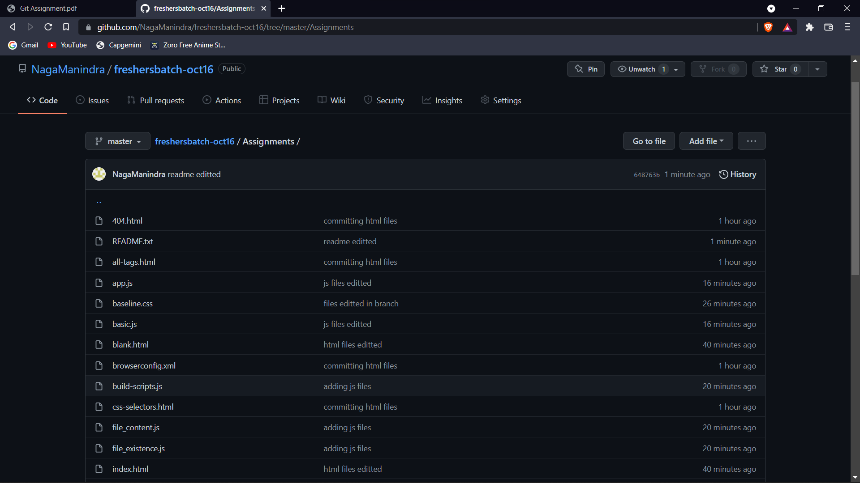

**SECTION-2**

**(Pushing source code to remote repository using Eclipse GIT plugin) - Steps to follow:**

**1. One developer from project team will create eclipse projects ‘SampleProj’ & add sample source code files. Then commit all files through eclipse GIT plugin.**

**2. Collaborate other team members with your github account so that they can also modify the committed files.**

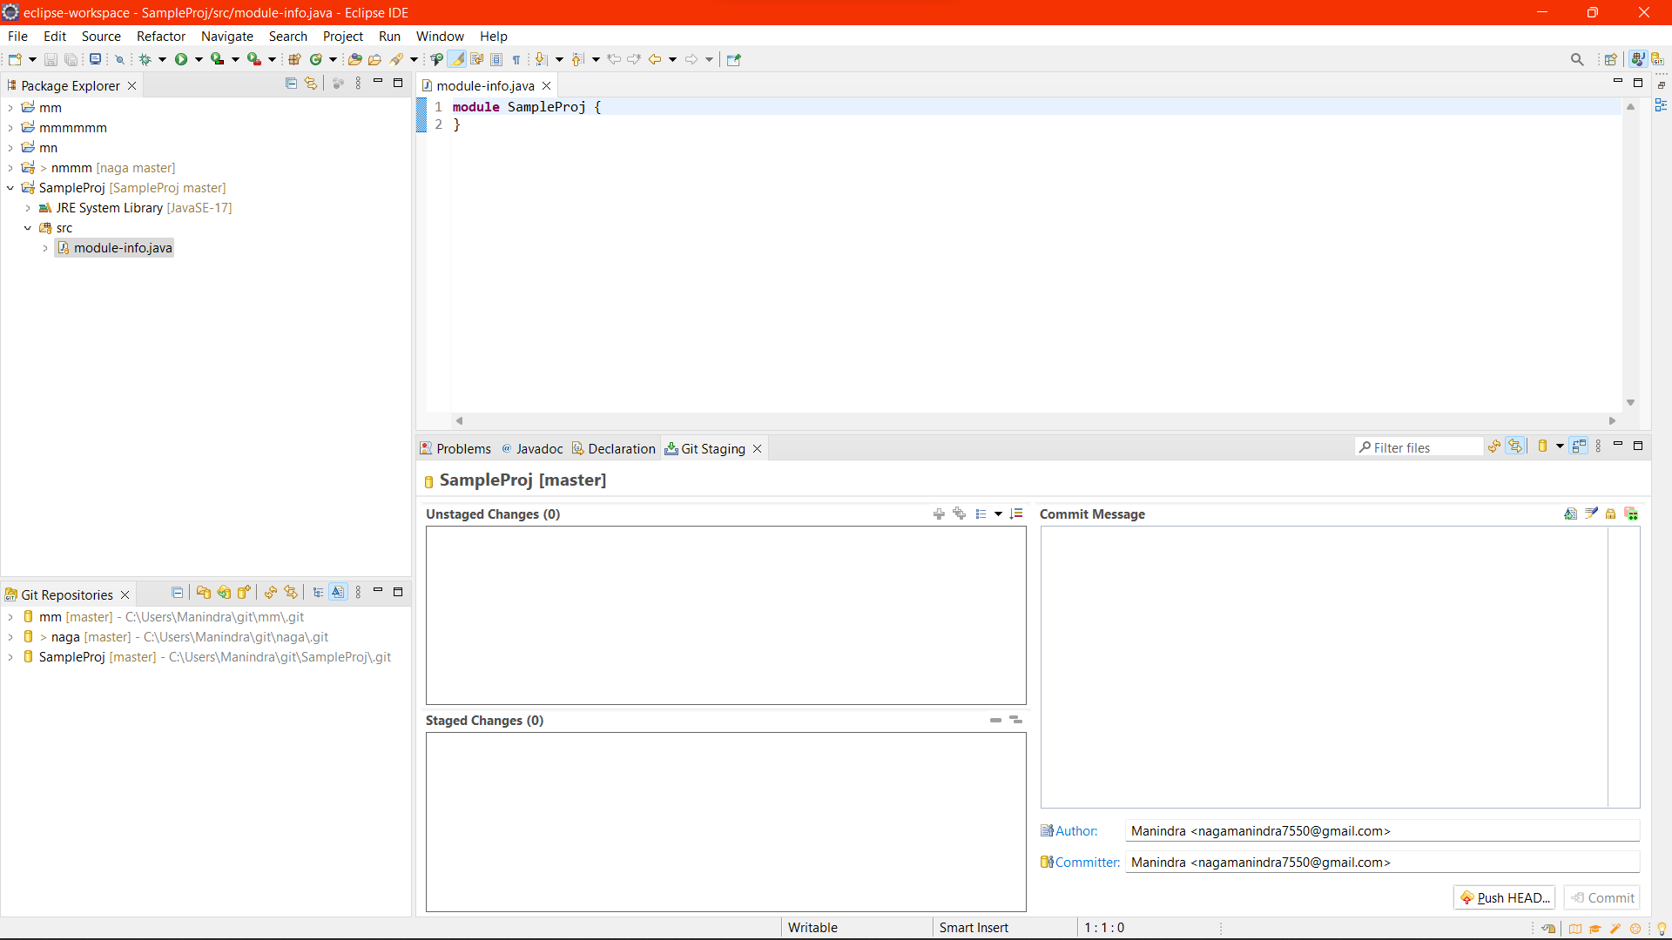

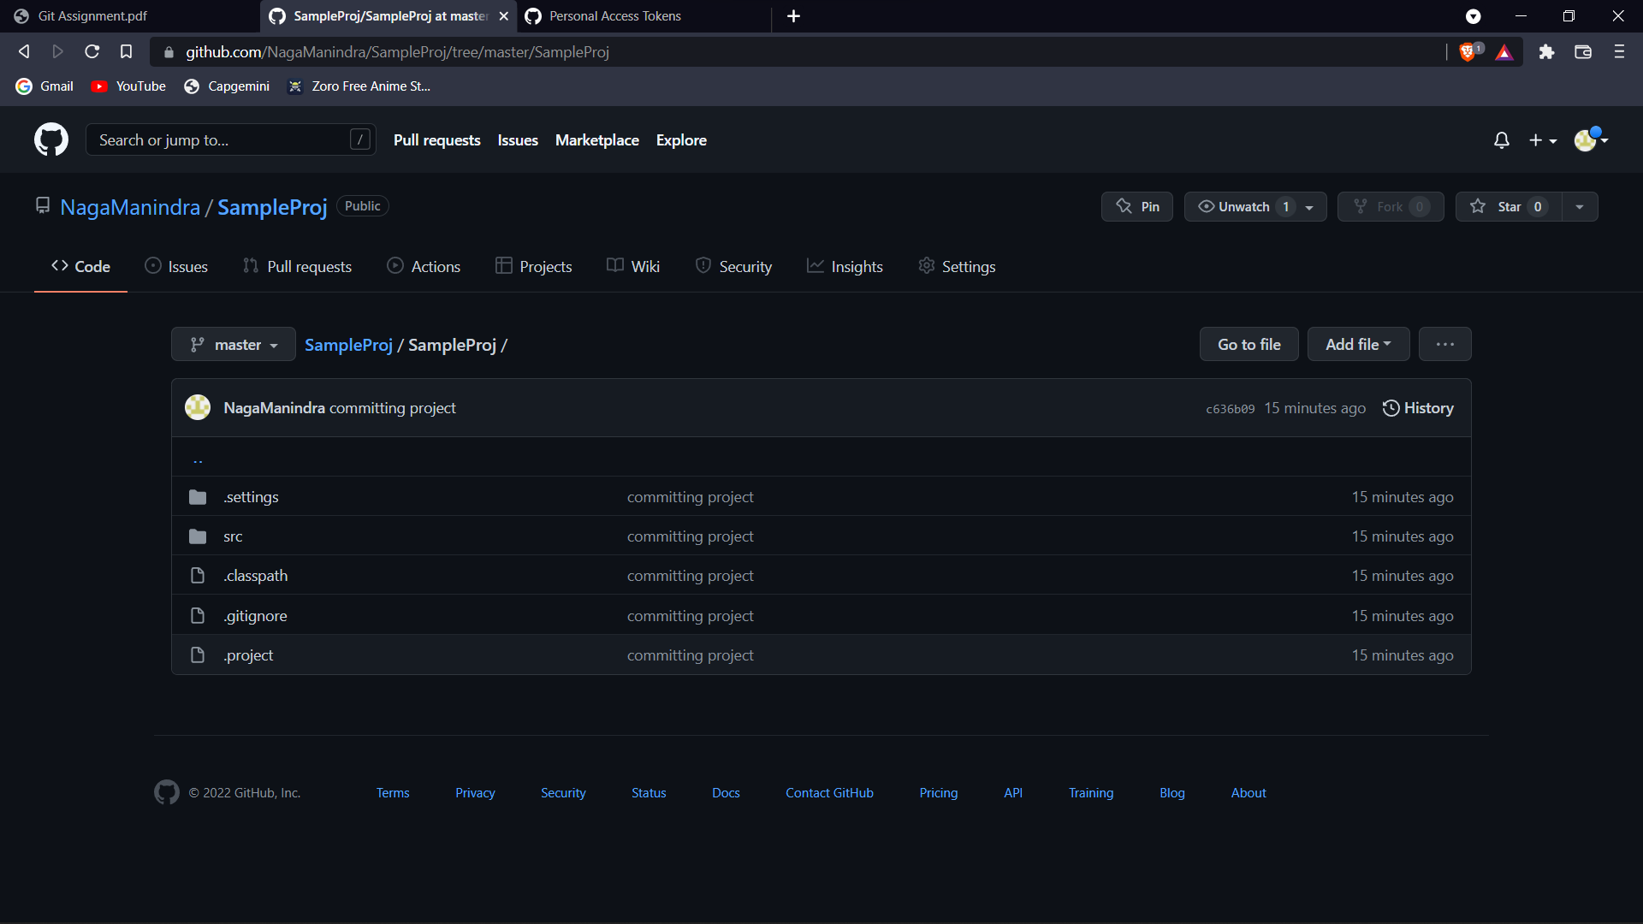

**3. Other developers from same team will checkout all files from remote repository. This might get conflicts since certain files fail to merge. In such case, merge it manually.**

**4. Commit & push the ‘SampleProj’ project.**

